May 2-4, 2025 :: Lake Ozark - [Camden on the Lake](https://camdenonthelake.com/)

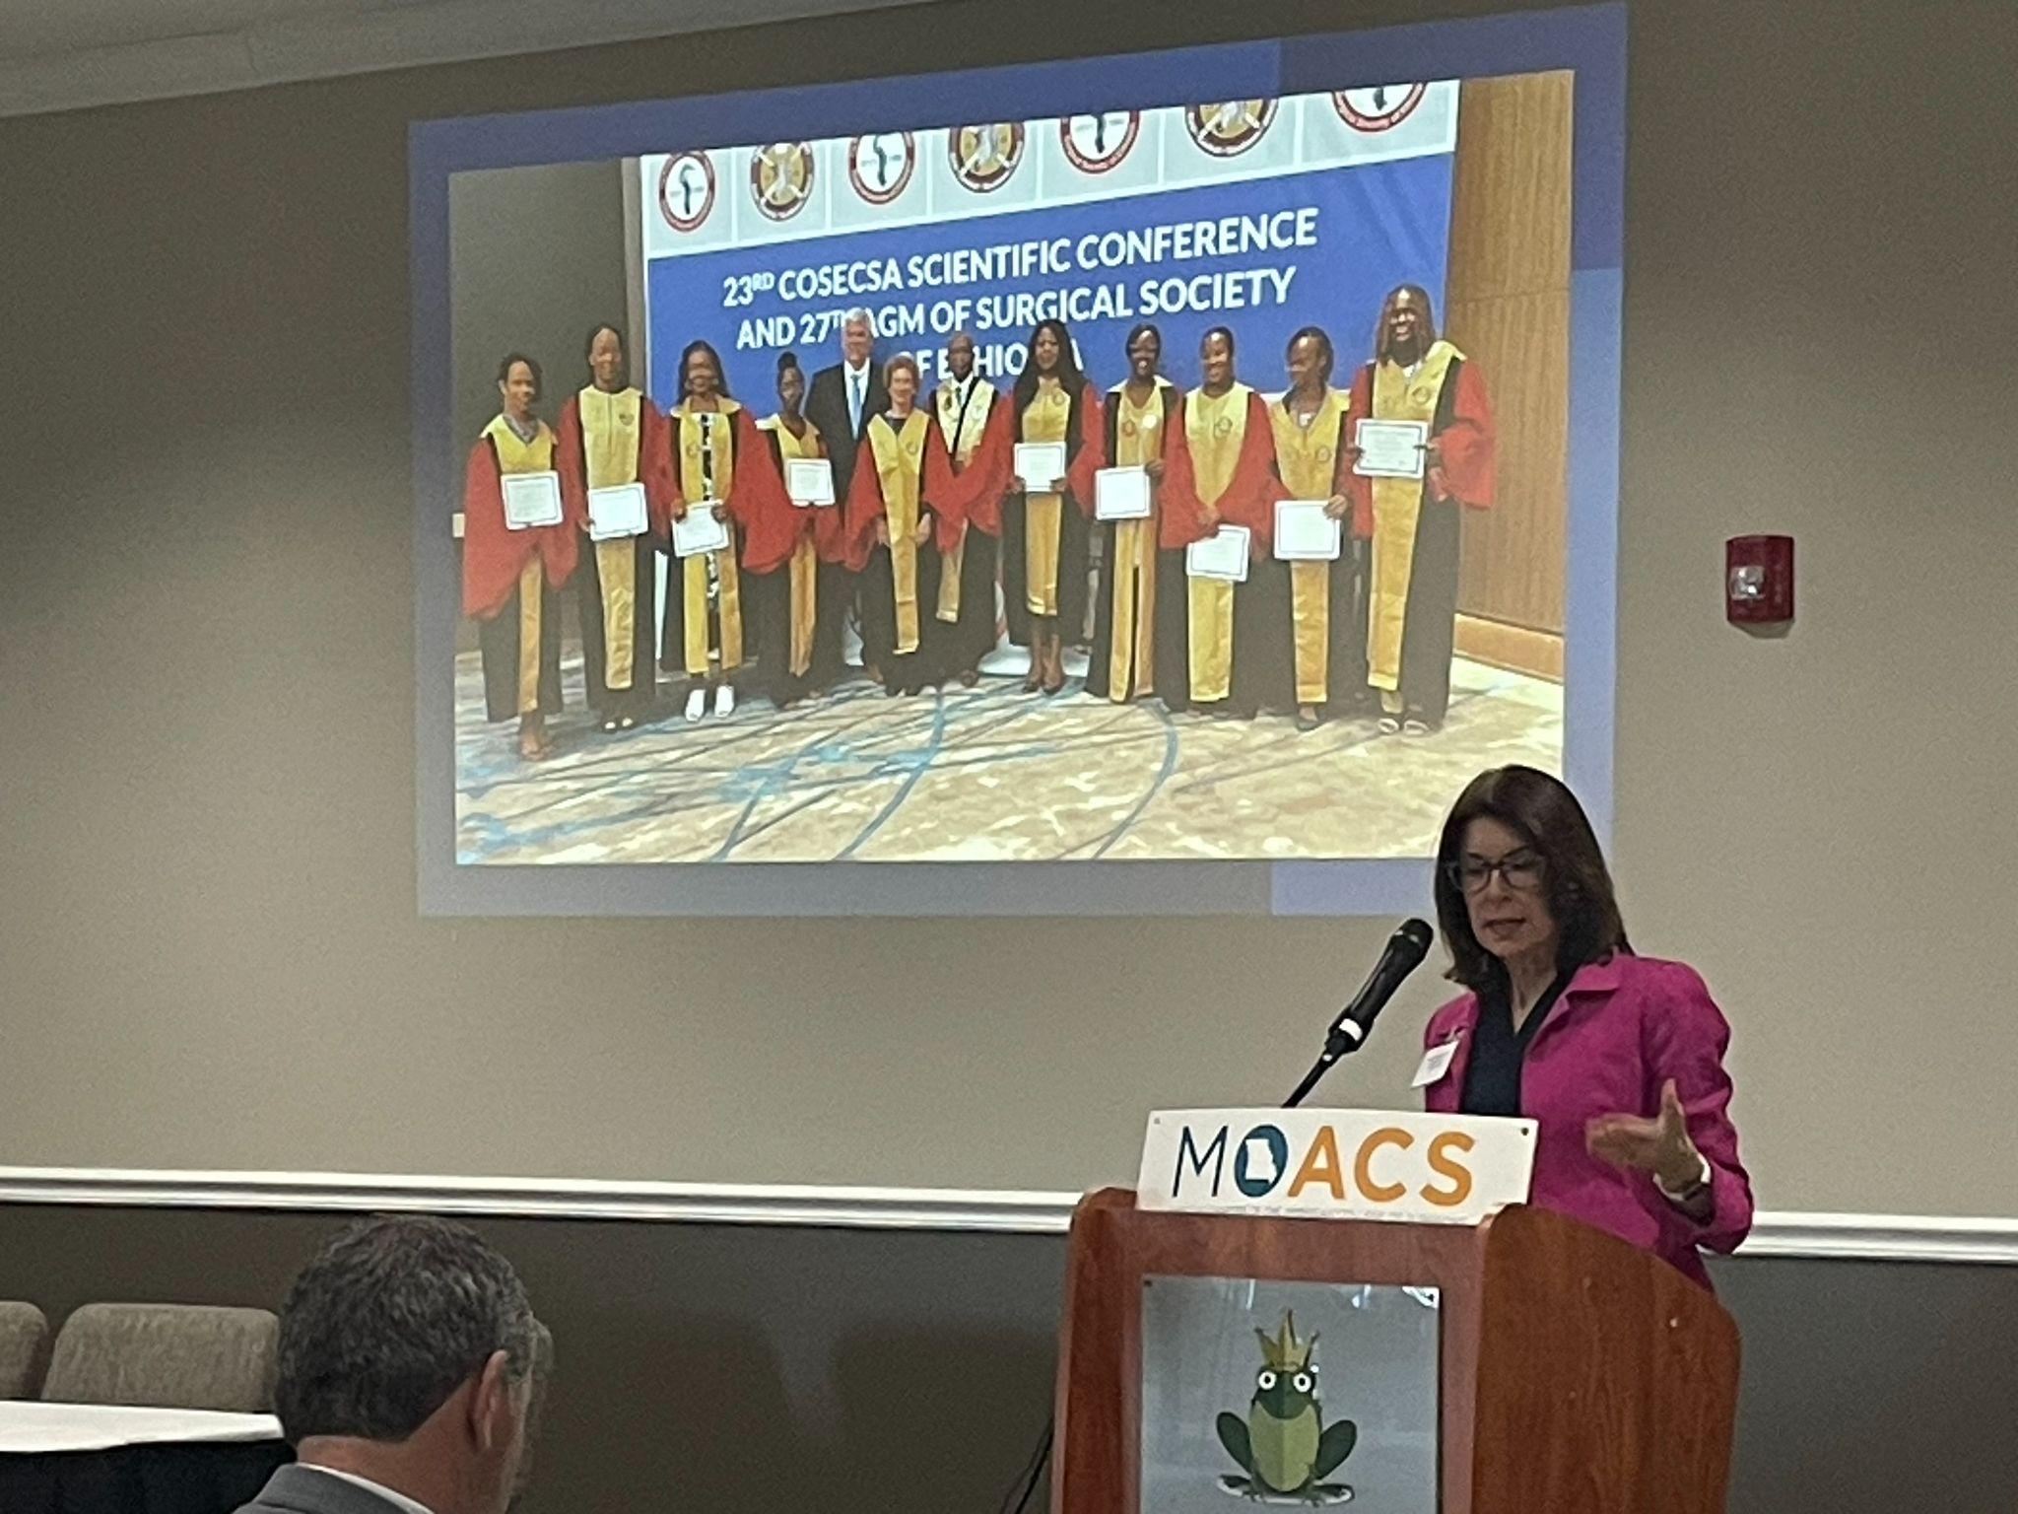[*CALL FOR ABSTRACTS*](https://www.moacs.org/_files/ugd/f59a3e_7e241b586aab4a5ca5fc4e5d61b62b60.pdf)

Deadline March 1, 2025

:: No Acceptance After Deadline ::   
:: Acceptance Notification Late March::

Abstract Submission Information

1. Sponsoring author must be a Fellow of the American College of Surgeons.

2. Word limit: 350 words for the entire abstract, not including the title, author string, or table/figure.

3. Structure: Introduction, Methods, Results, and Conclusions

4. Only one table or figure per abstract, without identifying information. Figures must be BMP, GIF, JPG, or PNG.

5. No identifying information should be included in the body or images of the abstract.

6. Videos and Quick Shots must adhere to the same abstract guidelines.

Presentation at MOACS generally does not preclude submission and presentation of the same work at national meetings, given that MOACS is a regional meeting of the American College of Surgeons. All submitted abstracts must be original works that have not been previously published or presented. There is no limit to the number of abstracts you may submit, however a single author may present no more than two abstracts. There is no fee for submission. Abstracts that use artificial intelligence (AI) to create any part of the work or abstract will not be accepted. All authors are expected to adhere to the ACS Statement of Integrity. No changes can be made after April 1, 2025. The abstract may be withdrawn up to April 14, 2025, but not after.

Trauma Papers Abstract submission for the Committee on Trauma paper competition follow different length guidelines. Please refer to [MO COT Paper Competition Abstracts](https://www.moacs.org/abstract-submission) for further details.

DisclosuresThe presenter **must** complete an [ACS disclosure statement](https://f59a3e1b-5024-409d-8020-739d566ef83c.usrfiles.com/ugd/f59a3e_d81e3028781a467abfe066128818e4c0.docx) during the submission process. Any submissions with incomplete disclosures after the submission deadline will not be reviewed.



PresentationIf accepted, you must be present at the meeting. Authors, and coauthors, who fail to present without prior notice, will be prohibited from presenting abstracts for two years.

Registration Presenters are **required** to register themselves for the meeting. Registration is FREE for presenters. Register at [moacs.org](https://www.moacs.org/annualmeeting).